Title: **Multisensory integration precision is associated with better cognitive performance over time in older adults: a large-scale exploratory study**

Authors: Rebecca J. Hirst1,2, Annalisa Setti2,3, Céline De Looze2, Rose Anne Kenny2,4, Fiona N. Newell1

1 School of Psychology and Institute of Neuroscience, Trinity College Dublin, Ireland

2 The Irish Longitudinal Study on Ageing, Trinity College Dublin, Ireland

3 School of Applied Psychology, University College Cork, Ireland

4 Mercer Institute for Successful Ageing, St. James Hospital, Dublin, Ireland

Corresponding author:

Rebecca Hirst, hirstr@tcd.ie

Institute of Neuroscience

Trinity College Dublin

Dublin, Ireland

**Abstract**

Age-related sensory decline impacts cognitive performance and exposes individuals to a greater risk of cognitive decline. Integration across the senses also changes with age, yet the link between multisensory perception and cognitive ageing is poorly understood. We explored the relationship between multisensory integration and cognitive function in 2875 adults aged 50 + from The Irish Longitudinal Study on Ageing. Multisensory integration was assessed at several audio-visual temporal asynchronies using the Sound Induced Flash Illusion (SIFI). More precise integration (i.e. less illusion susceptibility with larger temporal asynchronies) was cross-sectionally associated with faster Choice Response Times and Colour Trail Task performance, and fewer errors on the Sustained Attention to Response Task. We then used k-means clustering to identify groups with different 10-year cognitive trajectories on measures available longitudinally; delayed recall, immediate recall and verbal fluency. Across measures, groups with consistently higher performance trajectories had more precise multisensory integration. These findings support broad links between multisensory integration and several cognitive measures, including processing speed, attention and memory, rather than association with any specific subdomain.

**Keywords** - Sound-Induced Flash Illusion, Ageing, Cognitive function, Audiovisual, Multisensory

**Introduction**

Increasing evidence suggests sensory function is a modifiable predictor of cognitive decline. However the strength of this evidence appears dependant both on the measures of sensory function used and domains of cognition examined (for review see Roberts & Allen, 2016). When exploring sensory function and cognitive ageing, a wealth of information can be learnt from population ageing studies; these typically have very large sample sizes, contain a wide range of covariates and often assess measures longitudinally – facilitating exploration of how factors change over time. To date, most large-scale studies linking sensory function and cognition in ageing, have focused on unisensory measures, such as pure-tone audiometry (see Loughrey et al. 2018 for meta-analysis) or visual acuity (Lin et al., 2004; Lim et al., 2020). Only one study to date, The Irish Longitudinal Study on Ageing (TILDA), has introduced a measure of how multiple senses are combined, a process known as *multisensory integration*.

Links between sensory function and cognition in ageing might be stronger if measures extend beyond peripheral, unisensory, measures of sensory acuity (Roberts & Allen, 2016). For example, Humes et al., (2013) used several measures oftemporal sensory processing (e.g. gap detection, temporal order judgements and temporal masking) in hearing, vision and touch. They found that the relationship between age and “global cognitive function” was mediated by “global sensory function” across measures. These findings indicate the value of exploring perceptual function in a more global, multisensory, manner. Moreover, multisensory integration is altered in cases of mild cognitive impairment (MCI; Chan et al., 2015), reliably predicts MCI diagnosis (Murray et al., 2018) and plays an important role in cognitive functions more generally (Lehmann & Murray, 2005; for reviews see Shams & Seitz, 2008; Wallace, Woynaroski, & Stevenson, 2020). Most recently, a large study of 345 older adults found visuo-somatosensory integration was reduced in individuals with MCI or Dementia, when integration was modelled through response time gains (Mahoney & Verghese, 2020). Collectively, these findings warrant further consideration in large-scale ageing studies.

The Irish Longitudinal Study on Ageing (TILDA) is the first nationally representative ageing study to include a measure of multisensory integration within its healthcare assessment: the Sound-Induced Flash Illusion (SIFI) (Shams et al., 2000, 2002; for reviews see Hirst, McGovern, et al., 2020; Keil, 2020). The illusion occurs when presenting one visual flash with two auditory beeps results in the perception of two flashes, even though only one occurred. Critically, by delaying the time between the second beep and the flash-beep pair (i.e. increasing Stimulus-Onset Asynchrony, SOA) illusion susceptibility in young adults typically decreases (this is usually reported for SOAs greater than 70 ms e.g. Shams et al. 2002). SIFI susceptibility has been linked to cross-sensory interactions during early stimulus encoding (Mishra et al., 2007; Shams et al., 2005) as well as pre-stimulus brain states influencing the likelihood of integration (Chan et al., 2021; Keil et al., 2014). The appeal of this paradigm to large-scale studies is that it provides a quick-to-administer index of multisensory function with simple task instructions (“how many flashes did you see”).

Several studies using the SIFI have shown that, relative to young adults, older adults remain susceptible to the illusion over long SOAs i.e. SOAs greater than 70 ms (Chan et al., 2021; McGovern et al., 2014; Merriman et al., 2015; Setti et al., 2011, 2014; Stapleton et al., 2014). Sustained illusion perception at long SOAs suggests an increased tendency to integrate information over a broader time window in older age. The cross-sectional relationship between global cognition and multisensory perception has been previously explored within the TILDA dataset. Hernández et al. (2019) found that poorer global cognitive function, assessed via the Montreal Cognitive Assessment (MoCA), was cross-sectionally associated with increased SIFI susceptibility at longer SOAs. In the current article, we refer to sustained illusion susceptibility at long SOAs as reflecting less “precise” integration, whereby “precise” can be defined as limiting integration to signals that occur close in time i.e. a narrow temporal binding window. What remains unclear is whether SIFI susceptibility is associated with specific subdomains of cognition (e.g. processing speed, sustained attention, verbal fluency or memory) and, moreover, whether SIFI susceptibility is associated with differing trajectories of cognition over time. It is possible that certain subdomains of cognition might be more relevant to multisensory integration. Mahoney & Verghese reported that visuo-somatosensory integration was significantly associated to attention but not other subdomains of the Repeatable Battery for the Assessment of Neuropsychological Status (RBANS). However, although attention and integration appear linked, it is not clear that changes in attention account specifically for age-related change in multisensory integration, as several studies have found that multisensory selective attention remains intact with ageing (Hugenschmidt et al., 2009; Hirst et al., 2018). The goal of the current study was to understand better the cross-sectional and longitudinal relationships between multisensory (audio-visual) integration and cognition in ageing, first, by utilising several more specific cognitive and sensory measures included in TILDA in cross-sectional analyses and second, by identifying groups from within the TILDA sample showing different 10-year trajectories of cognitive function and comparing their patterns of multisensory integration.

**Methods**

TILDA is a population representative sample of individuals aged over 50 from the Republic of Ireland (for sampling design see Whelan and Savva, 2013). TILDA started in 2009 with data collection scheduled every 2 years. Figure 1 illustrates the structure of the TILDA study and the specific measures from each wave included in the current analysis. At the time of the current analysis, five waves of data from TILDA were available. Our primary measure, the Sound Induced Flash Illusion (SIFI), was included at wave 3.

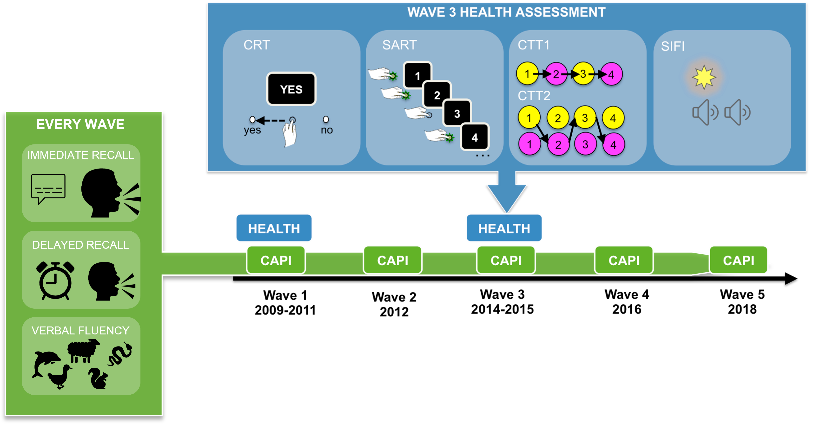

**Figure 1.** A schematic illustration of the TILDA study protocol. A Computer Assisted Personal Interview (CAPI) takes place at every wave, three of the measures from this were focused on in our longitudinal analysis; immediate recall, delayed recall and animal naming (verbal fluency).Health assessments took place at waves 1 and 3; the Sound Induced Flash Illusion (SIFI) was introduced at wave 3, the focus of this study.Three additional cognitive measures from the health assessment were examined in our analysis, left-right: the Choice Reaction Time (CRT) task; the Sustained Attention to Response Task (SART); The Colour Trails Task (CTT), see text for details*.*

**Participants**

To ease interpretation of the results, data from the same participants were included in both the cross-sectional and longitudinal analyses. An outline of inclusion/exclusion criteria is illustrated in Figure 2[1] and the demographics of the included sample are shown in Table 1. Participants must have completed the SIFI at wave 3 of TILDA alongside a full cognitive assessment and the longitudinal cognitive measures assessed from waves 1 through to wave 5 in our longitudinal analysis (see Figure 1). The study was approved by the Trinity College Faculty of Health Sciences Ethics Committee, testing protocols conformed with the Declaration of Helsinki and data were acquired, stored and processed in accordance with GDPR. All participants provided written, informed consent at each testing wave. Of note, 239 participants (8.3% of the final sample) had a MoCA score below 23 (the proposed criterion for MCI), and these individuals were predominantly in those groups with poorer cognitive trajectories (Table 1). We consider this in our interpretation of the results, particularly in terms of possible relationships between SIFI and cognitive impairment in ageing.

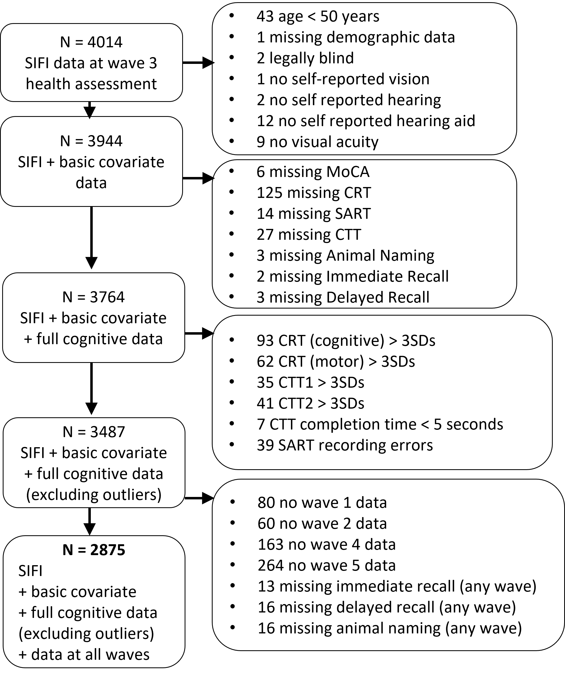

**Figure 2.** Protocol for selecting participants for this study from Wave 3 of TILDA. For tasks based on response times (Choice Response Time (CRT) and Color Trails Test (CTT) tasks) participants with values > 3 standard deviations from the mean (and, in the case of the CTT, completion times < 5 seconds) were excluded.

|  |  |  |  |  |  |  |  |  |  |  |  |
| --- | --- | --- | --- | --- | --- | --- | --- | --- | --- | --- | --- |
|  |  | Overall | Animal naming groups | | | Immediate recall groups | | | Delayed recall groups | | |
|  |  |  | A (N = 603) | B (N = 1297) | C (N = 975) | A (N = 1032) | B (N = 1244) | C (N = 599) | A (N = 1057) | B (N = 1182) | : C (N = 636) |
| Age | Min | 50 | 50 | 50 | 50 | 50 | 50 | 51 | 50 | 50 | 51 |
|  | Max | 92 | 85 | 87 | 92 | 86 | 87 | 92 | 85 | 87 | 92 |
|  | Mean (sd) | 63.96 (7.52) | 61.79 (7.21) | 63.44  (7.14) | 65.99 (7.71) | 61.32  (6.33) | 64.08  (7.25) | 68.25 (7.93) | 61.51  (6.56) | 63.98  (7.15) | 68.00 (7.93) |
| Sex | Female (%) | 1,585 (55) | 324 (54) | 726 (56) | 535 (55) | 693 (67) | 658 (53) | 234 (39) | 710 (67) | 628 (53) | 247 (39) |
|  | Male (%) | 1,290 (45) | 279 (46) | 571 (44) | 440 (45) | 339 (33) | 586 (47) | 365 (61) | 347 (33) | 554 (47) | 389 (61) |
| Edu. | Primary/  None (%) | 399 (14) | 36 (6) | 140 (11) | 223 (23) | 51 (5) | 163 (13) | 185 (31) | 74 (7) | 152 (13) | 173 (27) |
|  | Secondary (%) | 1,171 (41) | 153 (25) | 549 (42) | 469 (48) | 341 (33) | 567 (46) | 263 (44) | 360 (34) | 536 (45) | 275 (43) |
|  | Third/Higher (%) | 1,305 (45) | 414 (69) | 608 (47) | 283 (29) | 640 (62) | 514 (41) | 151 (25) | 623 (59) | 494 (42) | 188 (30) |
| MoCA score | n (%) < 23 | 239 (8) | 8 (1.33) | 64 (4.93) | 167 (17.12) | 15 (1.45) | 84 (6.75) | 140 (23.37) | 23 (2.17) | 79 (6.68) | 137 (21.54) |
|  | Min | 15 | 19 | 16 | 15 | 20 | 16 | 15 | 19 | 17 | 15 |
|  | Max | 30 | 30 | 30 | 30 | 30 | 30 | 30 | 30 | 30 | 30 |
|  | Mean (sd) | 26.50 (2.63) | 27.76 (1.93) | 26.86  (2.32) | 25.23 (2.85) | 27.81  (1.91) | 26.39  (2.34) | 24.45  (2.89) | 27.77  (1.97) | 26.37  (2.36) | 24.61 (2.86) |

Table1. Demographic information of overall sample and grouped by longitudinal trajectory group for Animal naming, Immediate recall and Delayed recall clusters. Trajectory groups are labelled as A, B and C corresponding to consistently higher performance, mid performance and low performance groups respectively.

**Performance measures and analyses**

The measures and analysis of the current investigation were twofold. First, we examined cross-sectional relationships between multisensory perception and cognition using the measures available in the healthcare assessment at the same time-point as the SIFI (i.e. at wave 3). Second, we used longitudinal cognitive measures available across waves 1 through to 5 to create cognitive trajectory groups and explore the relationship between SIFI and 10-year cognitive profiles. Both cross-sectional (at wave 3) and longitudinal measures (wave 1 to 5) are detailed below.

***Cross-sectional measures***

At wave 3, participants attended a health assessment for approximately 3 hours. All assessments were carried out by trained health nurses using a Standard Operating Procedure. See Figure 1 for an illustrated summary of the four relevant measures taken from wave 3 of TILDA. We considered all cognitive measures available cross-sectionally from the cognitive section of the healthcare assessment.

The Sound Induced Flash Illusion**:** Our primary measure of interest was susceptibility to the Sound-Induced Flash Illusion (SIFI; Shams et al., 2000). The SIFI procedure lasted approximately 6 minutes within the healthcare assessment. If the participant usually wore glasses or hearing aids, they also wore them during this assessment. The parameters of the paradigm used in TILDA have been outlined elsewhere (Hirst et al., 2019; Hirst, Setti, et al., 2020). Participants were seated in a testing room in front of a computer (Dell Latitude E6400 with Intel Core 2 Duo CPU, 2Gb RAM, 60 Hz refresh rate, using Windows 7 Professional OS) with a nurse who conducted the assessment. A fixation cross lasting 1000 ms marked trial onset. The visual and/or auditory stimuli were then presented. The visual stimulus comprised a white disc (1.5°visual angle, ~32 fl luminance), on a black background 5 cm below the central fixation cross for 16 ms. Viewing distance was approximately 60 cm. Auditory beeps were brief bursts of 3500 Hz sounds (10 ms, 1 ms ramp, approximately 80 dB) presented via the inbuilt laptop speakers.

In the first block, participants were asked to report how many flashes they saw. Visual stimuli could be presented alone (0B1F or 0B2F with an SOA of 70 ms), with a congruent number of auditory beeps (1B1F or 2B2F with the SOAs 70, 150 or 230 ms) or with an incongruent number of auditory beeps (2B1F, where the second beep was presented at one of six SOAs relative to the flash-beep pair; -230, -150, -70, 70, 150, and 230 ms, with negative SOAs indicating an auditory stimulus lead). Two trials from each condition were presented, in a random order for each participant. This block was preceded by a practice block containing one trial from each of the following conditions; 2B1F (SOAs; 70, 150, 230 ms), 2B2F (70 ms SOA), 1B1F, and 0B2F (70 ms SOA).

In the second block participants were asked to judge how many beeps they heard. This block contained two unisensory conditions 2B0F (SOAs; 70, 150 and 230 ms) and 1B0F in which auditory beeps were presented in the absence of visual stimuli. Two trials were presented from each condition, in a random order for each participant.

Choice Reaction Time (CRT) task**:** Participants were presented with words onscreen that read either “YES” or “NO”. Participants responded to the words using a keypad containing three buttons: one labelled “YES” one labelled “NO” and one central button with no text. Participants were instructed to hold their finger down on the central button and, as soon as they saw the onscreen word, release the button and press one of the “YES”/”NO” keys depending on the word presented onscreen. The words “YES” or “NO” were presented on screen 50 times with varied onset from 800 – 1100 ms from the time when the participant pressed the central button, indicating the start of the trial. Each stimulus remained onscreen until the participant made a “YES”/”NO” response. Two measures of reaction time were obtained: the time at which the finger was released from the central key (‘cognitive’ reaction time) and the time at which the “YES”/”NO” key was pressed (‘motor’ response time) (Cronin et al., 2013).

Sustained Attention to Response Task (SART) (Robertson et al., 1997): Participants were presented with the digits 1 - 9 sequentially on screen in consecutive order. Each digit appeared for 300 ms, with an inter-stimulus-interval of 800 ms. The cycle of digits 1 – 9 was repeated 23 times (207 trials in total). Participants were instructed to press the spacebar in response to every digit, but to withhold a response to the digit ‘3’. Commission errors (pressing in response to the number 3) and omission errors (failing to press in response to any of the other digits) were considered for analysis.

Colour Trails Test (CTT): The CTT is a pen-to-paper task comprised of two subtasks. For the Colour Trails 1 test (CTT1), the participant is instructed to draw a line connecting circles numbered 1 through 25 in consecutive order. The fact that the colour of the circle alternates with each succeeding number is not mentioned to the participant. For the Colour Trails 2 trail (CTT2), the examiner instructs the participant to draw a line between numbered circles, maintaining the sequence of numbers, but this time alternating between pink and yellow colours (in CTT2, each number has both a yellow and pink circle, so the participant must choose the correct circle). Both tasks must be performed as quickly as possible without errors. If an error is made, the examiner points it out and instructs the participant to correct the error and proceed with the task. Up to 10 seconds are allowed for the participant to make a connection between one circle and the next. After the 10-second period has elapsed, the examiner provides a non-verbal prompt (i.e. by pointing) indicating the position of the next correct circle. We explored the total time required to complete CTT1 (basic processing speed) and the CTT2-CTT1 difference score (i.e. CTTdelta, indicating the effect of the additional task CTT2 element) in our analysis.

***Longitudinal measures***

Longitudinal measures of cognitive function were obtained from a Computer Assisted Personal Interview (CAPI), which is delivered at every wave of TILDA. A trained interviewer attended the participant’s home and delivered a standardised set of questions. Three measures were selected for the current analysis on the basis that these measures had been shown to be more sensitive to longitudinal change within the TILDA cohort (Feeney & Tobin, 2018): Immediate recall, Delayed recall and Verbal fluency (animal naming).

Immediate recall:Participants were presented with an audio recording of 10 words,with one word presented every 2 seconds(the list of words wasrandomly selected for each participant from the lists shown in Supplementary Table S7). Before presenting the word list, a sample audio recording of the computer voice was presented so that participants could adjust the volume of the computer to an appropriate level. If the participant could not hear the computer voice the word list was read aloud by the interviewer, who was instructed to deliver the words at approximately the same pace (1 word every 2 seconds). Immediately following the presentation of the word list participants were asked to recall as many words as they could within a minute. The list was then repeated and participants were again asked to recall as many words as they could, including the words they recalled earlier. The scores from both attempts are then summed to derive an immediate recall score out of a total of 20.

Verbal fluency**:** Following the test of immediate recall participants were asked to freely name as many animals as they could within one minute. The total number of animals named was recorded as the measure of verbal fluency included in our analysis.

Delayed recall**:** Following the test of immediate recall and animal naming, participants were then asked several questions regarding their physical and cardiovascular health, which acted as intermediatory tasks. The exact number of questions asked of each participant on these topics varied depending on whether follow-up questions needed to be asked. The average time between the first and delayed recall session was estimated to be 12 min 37 seconds, *SD* = 5 mins, based on time stamps for participants who received the computer read out lists obtained at wave 2 of TILDA. Following the intermediatory questions, participants were asked to recall the word list delivered earlier in the test of immediate memory. Each participant’s score out of a total of 10 was used as our measure of delayed recall.

**Data analyses**

All statistical analyses were performed within the R statistical programming environment, version 3.5.2 (R CoreTeam, 2018). Our dependent variable for all models was accuracy for judging the number of flashes on the illusory 2B1F trials of the SIFI. This score represented the proportion correct (0, 0.5 or 1) for each participant. In both cross-sectional and longitudinal analyses, we therefore implemented generalized logistic mixed-effect models using “glmer” in the “lme4” package (family = “binomial”) (Bates et al., 2015). All tables and figures were created using the sjPlot package (Lüdecke, 2021). All analysis scripts and resulting tables/figures can be found here <https://github.com/RebeccaHirst/TILDA_multisensory_cognitive> (for peer review this can be accessed here <https://osf.io/9de5z/?view_only=7f94fde12cec4e96a9cc022095ccc515> ). The difference between our cross-sectional and longitudinal analyses was that our longitudinal analysis was preceded by cluster analysis, used to identify groups with differing longitudinal cognitive trajectories. The primary analysis in both cross-sectional and longitudinal approaches was a set of logistic mixed effects models with SIFI susceptibility as an outcome measure; and cognitive function, or cognitive-trajectory group, as the independent predictor. This approach enabled us to address whether current cognitive functions, or cognitive trajectories, are associated with multisensory integration i.e. susceptibility to the SIFI.

Cross-sectional statistical analysis

For each model (CRT, SART and CTT), our dependant variable was accuracy on the 2B1F condition of the SIFI. Fixed-effects of interest were Stimulus Onset Asynchrony (SOA; 70 ms, 150 ms, or 230 ms), cognitive performance (defined individually for each model) and whether there was an interaction between SIFI SOA and cognitive performance (indicating different patterns of multisensory integration dependant on cognitive performance). Participant ID was held as a random effect. All models are reported adjusted for the following factors: whether the second beep preceded/led or followed the flash beep pair (termed “Pre/Post” respectively), age in years, sex of the participant (male/female), education level (Primary, Secondary, Third/Higher), self-reported vision and self-reported hearing (Excellent, Very Good, Good, Fair, Poor), Visual Acuity Score (VAS = 100 – 50 x LogMAR, so that a VAS of 100 represents a LogMAR score of 0 (20/20 vision), higher scores therefore indicate better acuity), accuracy for judging 2 beeps alone (2B0F) at 70 ms, accuracy for judging 2 flashes alone (0B2F) at 70 ms and accuracy for judging the number of flashes when 1 beep and 1 flash were presented together (1B1F), Chronic conditions (0, 1 or 2+ of the following: Parkinson’s, lung disease, asthma, arthritis, cancer, osteoporosis), Cardiovascular conditions (0, 1, or 2+ of the following: TIA, stroke, heart attack, heart murmur, heart rhythm, angina) and depression (Yes or No based on a CESD score of >= 9)[2] . Because age and sex had previously been shown to interact with SOA (Hernández et al., 2019), we also controlled for these interaction terms across models. All continuous, numeric variables were scaled and centred prior to inclusion in the model using the scale() function in R with default parameters.

To answer our primary research question, which was whether cognitive performance was associated with multisensory integration, we tested whether each cognitive measure significantly interacted with SOA (indicating different patterns of multisensory integration). The significance of each cognitive score by SOA interaction term was assessed using likelihood ratio tests to compare the model with the interaction term to the model without the interaction term (the additive model) using the “anova()” function in R. Because we conducted three parallel models (CRT, SART & CTT), each with two subdomains that could interact with SOA (i.e. the CRT task had motor and cognitive response times; the SART had omission and commission errors; the CTT had CTT1 and CTTdelta), six likelihood ratio tests were conducted. We thus considered a Bonferroni adjusted alpha of .008 as significant, correcting for 6 likelihood tests in total.

Longitudinal statistical analysis

Measures of immediate recall, delayed recall and verbal fluency were available for 5 waves of the TILDA study (providing 10 years-worth of data per participant). We used k-means clustering (using the kml package in R; Genolini et al., 2015; Genolini & Falissard, 2011), followed by cluster validation, to identify subgroups with different 10-year cognitive trajectories for each of these measures independently. Each algorithm was set to test up to 5 clusters with 100 permutations. Cluster solutions were then compared across several validation metrics used to compare within-cluster similarity to between-cluster distinctness (i.e. “cluster compactness”). The metrics used were the Calinski and Harabatz (standard, Kryszcuzuk and Genolini variants), Ray and Turi and Davis and Bouldin criterion. In the kml package, scores closer to 1, across validation metrics, are considered better (for details see Genolini et al., 2015). Since utilising several validation metrics may increase the reliability of cluster selection (Genolini & Falissard, 2011), we selected the number of clusters yielding the highest value across all metrics.

To explore the relationship between cognitive trajectories and multisensory integration at wave 3, the identified groups were included as predictors in logistic mixed effects models with SIFI accuracy as an outcome measure (as described for cross-sectional analyses). We report all models adjusted for the same covariates reported in the cross-sectional analyses and consider a Bonferroni corrected alpha adjusted for three comparisons as significant (0.016).

**Results**

***Cross-sectional results***

A summary of the results from each cross-sectional model is shown in Figure 3 (for full results of all model terms see Supplementary material). As expected based on previous studies from TILDA, age and sex interacted with SOA, showing that older participants and females were less accurate on the SIFI (i.e. more susceptible) at longer SOAs (notably, there was no main effect of age at reference).

**Choice Reaction Time (CRT) task:** From the CRT task we can extract cognitive response time (the time taken to lift the finger off the central button) and motor response time (the time taken from the initial lift to press the selected response key). We tested if each of these terms interacted with SOA.

A likelihood ratio test comparing the full model to a model without the cognitive response time by SOA interaction term indicated that the inclusion of this term significantly improved the model fit χ2(2) = 21.50, *p* = < 2.143-e05.Similarly, a comparison of the full model to a model without the motor response time by SOA interaction term indicated this term significantly improved the model fit χ2(2) = 73.096, *p* < 2.2e-16. As shown in Figure 3a, longer motor and cognitive response times were associated with less accurate performance at longer SOAs on the SIFI (indicating stronger illusion susceptibility).

**Sustained Attention to Response Task (SART):** The SART task comprises both errors of omission and commission. We considered if each of these error types interacted with SOA.

A likelihood ratio test comparing the full model to a model without the Commission error by SOA interaction term indicated this term reached significance, χ2(2) = 9.86, *p* = 0.006. A comparison of the full model to a model without the Omission error by SOA interaction term indicated this term significantly improved model fit χ2(2) = 18.475, *p* = 9.73-e05. As shown in Figure 3b higher numbers of errors were associated with lower accuracy (i.e. greater susceptibility) on the illusory SIFI condition at longer SOAs. When considering these factors independently of SOA, these effects were much smaller and non-significant.

**Colour Trails Task (CTT):**The CTT task also comprises two sub-measures, CTT1 (the time taken to connect numbers without needing to consciously switch between colours) and the CTT2 (the time taken to connect numbered circles whilst also selecting and alternating between pink and yellow circles), CTTdelta indicates the CTT2-CTT1 difference score, and is what we examined to understand the specific contribution of CTT2.

For CTT1 a likelihood ratio test comparing a model without the CTT1 by SOA interaction to a model with the CTT1 by SOA interaction term showed that by including this interaction term it significantly improved the model fit χ2(2) = 85.381, *p* = < 2.2e-16. Similarly, for CTTdelta a likelihood ratio test comparing a model without the CTTdelta by SOA interaction to a model with the CTTdelta by SOA interaction term was significant χ2(2) = 75.14, *p* = < 2.2e-16. Together these results suggested that both aspects of the CTT were significantly associated with SIFI susceptibility at longer SOAs.

Notably, across cognitive measures the interaction with SOA revealed the observed relationships, suggesting it is important to consider SOA when examining the relationship between cognitive function and multisensory perception in this task.

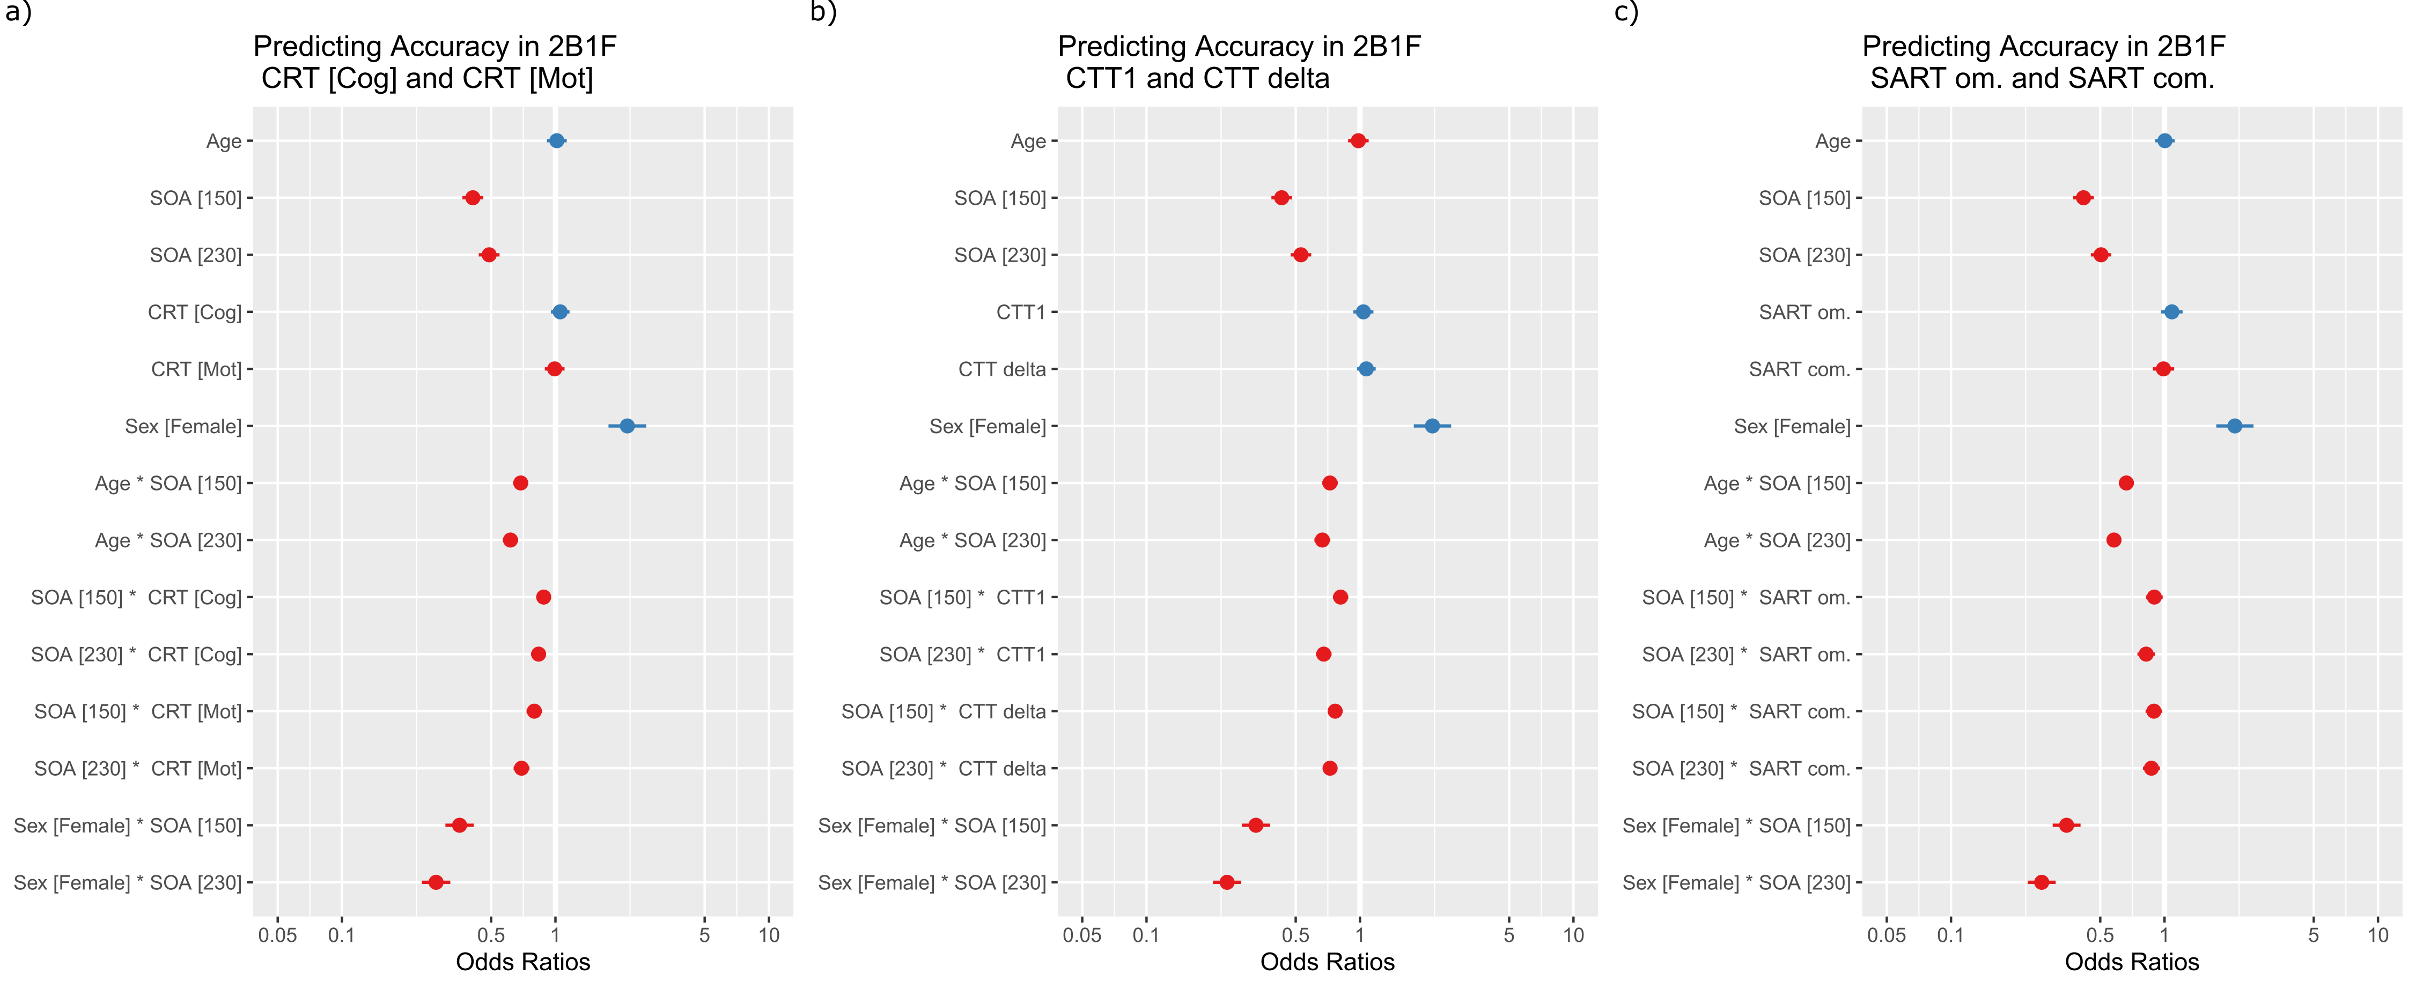

**Figure 3.** Cross sectional analysis of performance in *a)* Choice Reaction Time (CRT), including cognitive response time and motor response times *b)* Colour Trials Task (CTT1 and CTTdelta) and *c)* Sustained Attention to Response Time (SART), including Omission and Commission errors. Odds ratios indicate the odds of a correct response on the illusory 2B1F condition of the SIFI task (lower odds of accuracy is equivalent to higher odds of being susceptible to the SIFI).

***Longitudinal results***

A solution of 3 clusters was selected as optimal for all cognitive measures (see Supplementary Figure 1). The resulting trajectory groups are shown in Figure 4 a-c. These groups were then used as predictors in logistic mixed-effect models with the consistently highest performing trajectory group (group A across models) set as the reference in each model. In general , we will use the terms “high performance group”, “mid performance group” and “low performance group” to refer to groups A, B and C respectively across measures. For characterization of how each group changed in performance across 10 years, we performed t-tests comparing performance at wave 1 to wave 5 (the results of these analyses are shown in Supplementary material). In both immediate and delayed recall cluster groups, the high performance group increased in performance across waves. For verbal fluency the high performance, and other cluster groups, showed declines from waves 1 to 5. As shown in Table 1, there was a higher proportion of individuals with a MoCA score below 23 in the “low performance” group across clusters.

**Immediate recall:** The interaction between immediate recall group and SOA significantly improved the model fit ($X^{2}$ (4)= 90.223, p < 2.2e-16). As shown in Figure 4d groups B (mid) and C (low) had lower accuracy relative to the most cognitively group A (high) and this was most pronounced at longer SOAs. Moreover, this pattern was most evident in the low cognitively performing group (group C).

**Delayed recall:** The interaction between the delayed recall group and SOA significantly improved the model fit ($X^{2}$ (4)= 62.548, p = 8.3e-13). Similar to immediate recall, groups B (mid) and C (low) had lower accuracy relative to the most cognitively high performing group (group A) and this was most pronounced at longer SOAs (Figure 4e).

**Verbal fluency (animal naming):** The interaction between the verbal fluency group and SOA significantly improved the model fit ($X^{2}$ (4)= 90.231, p < 2.2e-16). Those scoring consistently lower across waves (groups B and C) had lower accuracy on the SIFI relative to the high cognitively performing group (group C) and this was most pronounced at longer SOAs (Figure 4f).

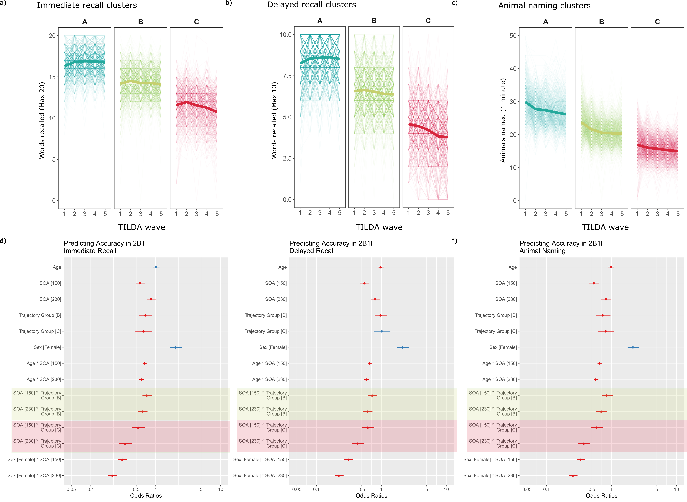

**Figure 4.** *a – c)* Cluster trajectory groups for measures of immediate recall, delayed recall and verbal fluency. Groups were labelled as “A”, “B” and “C” reflecting the highest to lowest performing trajectories. Note that different participants can be allocated to different groups depending on measure (i.e. an individual belonging to group A for immediate recall, does not necessarily belong to group A in delayed recall and verbal fluency). *d – f )* Results of the logistic mixed effects models with the factor of longitudinal ‘cognitive trajectory group’ as a predictor. Effects relating to trajectory groups are shaded in corresponding colours, the highest performing group was held as reference. Across models the interaction between trajectory group and SOA was significant, with those in the less healthy trajectory groups scoring less accurately (i.e. greater susceptibility) on the illusory SIFI conditions.

**Discussion**

In this study we explored whether multisensory function was associated with specific subdomains of cognitive function and cognitive trajectories, in a sample of 2875 older adults. Cross-sectionally, multisensory function, assessed using the Sound-Induced Flash Illusion (SIFI), was associated with all measures of cognitive function considered. Those with slower motor and cognitive response times, more errors on the SART and slower performance on the Colour Trails Test were all more susceptible to the SIFI at longer SOAs. Longitudinally, trajectories of immediate recall, delayed recall and verbal fluency (animal naming) were all similarly associated with SIFI. Those with consistently poorer performance on these cognitive tasks were more susceptible to SIFI at longer SOAs. The current findings indicate multisensory integration, measured using the SIFI, is associated broadly with measures of memory, processing speed, executive function and sustained attention, rather than being specifically associated with one or two types of cognitive measures.

To date, several empirical studies have investigated the relationship between SIFI susceptibility and cognitive function. In young adults, SIFI susceptibility increases with high cognitive load (Michail & Keil, 2018), suggesting illusion perception could be tied to cognitive resources. In older adults, Chan et al. (2015) reported increased illusion susceptibility at longer SOAs in older adults with MCI. However they did not find specific relationships with sub-dimensions of the Consortium to Establish Registry for Alzheimer’s disease (CERAD), and thus interpret SIFI performance as relating to global cognitive function. In younger and older adults, DeLoss et al., (2013) found that performing a dual visual or auditory go-no/go paradigm at the same time as the SIFI task influenced illusion susceptibility; performing a visual go-no/go task decreased illusion susceptibility rate whilst auditory go-no/go task increased illusion susceptibility rate, which DeLoss et al. interpret in the framework of attentional biasing. However, this effect of attention did not differ between age groups, therefore DeLoss et al. conclude that age-related differences in SIFI might not be associated with age differences in the ability to inhibit task-irrelevant information.

The current findings align with the findings of Chan et al., (2015), in that multisensory integration did not appear tied to a specific domain of cognitive function. When considering the conclusions of DeLoss et al., we also saw that the interaction between age and SOA remained significant, even when the interaction between cognitive function and SOA was in the same model. This is also consistent with the conclusion that although cognitive functions were related to SIFI performance, age-related differences in SIFI susceptibility may not be attributable to differences in cognitive function alone.

A question arising from these findings is whether multisensory integration is an indicator of general cognitive health or of current cognitive state. It is possible that susceptibility to the SIFI is influenced by global brain health because it shares a common neural mechanism with other cognitive measures. The prefrontal cortex has been identified in the literature as a seat of common cause, providing top-down modulation of processing in sensory cortices as well as playing an important role in cognition (Knight et al., 1999). In the TILDA cohort, we have observed that the SIFI is associated with specific volumetric changes in the right Angular Gyrus (Hirst et al., 2021), a structure that has been described as a hub for bottom up and top-down integration with several global functions ( for review see Seghier, 2013). Such integrative processes are likely to be required for a range of perceptual and cognitive functions in older adults, as such, it is possible that deterioration of a common, or ‘domain general’ mechanism accounts for performance across several perceptual-cognitive tasks (for a discussion of example domain general mechanisms see Assem et al., 2021). Of note, we did not exclude participants based on their MoCA score, in order to observe a wider spectrum of cognitive performance that might be indicative of impairment. Following this, within our longitudinal analyses, a higher proportion of individuals in the “consistently low performing” groups had a MoCA score below 23, indicating potential for cognitive impairment (17-21 % depending on trajectory group – Table 1). Based on this, it is tempting to consider that greater SIFI susceptibility might be tied to risk of cognitive impairment in ageing, as has been previously observed (Murray et al., 2018). However, whilst it might be tempting to consider directional interpretation in terms of whether multisensory perception predicts cognition or vice versa, we cannot currently draw such conclusions from the available data, but it is likely that with future waves of TILDA data collection, such analyses will be possible.

An alternative explanation of the observed cross-sectional links could be that cognitive measures provided an indication of the current brain state of the individual at the time at which they completed the SIFI task. It is known that pre-stimulus brain states are critical to whether illusions are perceived or not in the SIFI (Chan et al., 2021; Keil et al., 2014). In the TILDA healthcare assessment, all cognitive measures are completed first followed by sensory measures, therefore it could be argued that cognitive measures reflect the current brain state (i.e. alertness), rather than a longer term cognitive profile. Nevertheless, the observed global links between multisensory integration and cognition applied both in our cross-sectional analysis as well as with longitudinal cognitive trajectories, suggesting the findings may provide a more general measure of brain health beyond the current state.

What did appear important across analyses was to consider the interaction between SOA in the SIFI task and cognition. This is in line with the broader SIFI literature showing that SOA typically interacts with group to reveal differences in multisensory dynamics (e.g. Setti et al., 2011). The relationship between SIFI and cognitive measures were most prominent across measures at the longer Stimulus Onset Asynchronies. This suggests that for studies wishing to explore the relationship between the SIFI and cognitive function, the manipulation of SOA in the SIFI task appears pertinent. The specific relationship between cognitive function and SOA in the SIFI appeals to the temporal dynamics of multisensory integration, rather than general multisensory performance. This is in line with previous studies reporting specific links between temporal aspects of multisensory processing and cognition (e.g. Hume et al., 2013).

Large-scale studies such as TILDA provide a unique avenue to exploring multisensory function and its relationship with cognition in ageing. Nevertheless there are several limitations and notes of caution that apply to the current approach. First, despite the very large number of participants involved, the number of trials tested on the SIFI were necessarily limited. Due to time constraints of the TILDA protocol, there were two trials per SIFI condition tested (i.e. 12 illusory trials overall for each participant). Since perceptual learning is thought to play a key role in how we perceive multisensory events, for example exposure to more SOAs can decrease illusion susceptibility in the SIFI (Chan et al., 2018) we cannot confirm whether the current effects could be expected if more trials or conditions were included. Nevertheless our results, particularly those relating to age and SOA, are consistent with those reported from studies including a larger number of trials (see e.g. McGovern et al., 2014). Another limitation arises in our longitudinal analyses, in that currently our primary outcome measure is only available at wave 3 of TILDA (a central time-point), whereas our cognitive trajectories were derived using five timepoints (for better k-means fitting), therefore it is difficult to determine directionality or causality in the relationship between multisensory function and cognition. We hope that this latter question will be addressable as future waves of TILDA progress, providing more cognitive and multisensory data for exploration whether multisensory perception might provide insight into cognitive health.

Understanding causality should be a key driver for future research in this field. In particular, if multisensory integration is predictive of cognitive decline, then multisensory training could in turn be considered an avenue to supporting healthy cognitive ageing. Studies have already begun exploring whether perceptual training (Merriman et al., 2015; O’Brien et al., 2020) or lifestyle factors such as exercise (O’Brien et al., 2017) can improve efficiency on the SIFI. Nevertheless, there is a need to understand individual differences in these effects and why not all individuals may show improvement (Setti et al., 2014).

**Conclusion**

In sum, we found that several cross-sectional and longitudinal measures of cognitive function were associated with multisensory function in a large cohort of older adults. The strengths of this study include the large sample size and range of measures that we were able to assess, in addition to the covariates that we were able to control for. Our findings do not point towards a single domain of cognition that appears most strongly associated with multisensory perception, but instead support more global relationships between cognition and perception in ageing.

**Competing interests:** The authors have no conflict of interest to declare

**Data and Code availability:** All analysis code is available here <https://github.com/RebeccaHirst/TILDA_multisensory_cognitive> (for peer review this can be accessed here <https://osf.io/9de5z/?view_only=7f94fde12cec4e96a9cc022095ccc515> ). To access the data please contact the TILDA team <https://tilda.tcd.ie/data/accessing-data/>. At present, the multisensory data used in the current manuscript is not yet in the public release and must be accessed via the Hot Desk facility.

**Acknowledgements:** This work was supported by the Health Research Board (HRB); Grant reference ILP-PHR-2017-014. We would also like to thank Alan O’Dowd for his feedback in shaping this manuscript as well as members of the TILDA team, for their helpful feedback in drafting previous versions of this manuscript.

**Author contribution statement:** The Irish Longitudinal Study on Ageing (TILDA) is an interdisciplinary project co-ordinated by R.A.K.A.S and F.N.N designed the protocol for the Sound-Induced Flash Illusion incorporated into TILDA. Together, R.J.H., C.DL, A.S. and F.N.N. developed the analysis plan for this study; R.J.H. conducted the analysis and prepared the manuscript. A.S and F.N.N. contributed to the theoretical interpretation of the results. All authors provided feedback and revisions on the manuscript and approved the final version of the manuscript for submission.

**References**

Assem, M., Shashidhara, S., Glasser, M. F., & Duncan, J. (2021). Precise topology of adjacent domain-general andsensory-biased regions in the human brain. *BioRxiv*. https://doi.org/10.1101/2021.02.21.431622

Bates, D., Maechler, M., Bolker, B., & Steve, W. (2015). Fitting Linear Mixed-Effects Models Using lme4. *Journal of Statistical Software*, *67*(1), 1–48. https://doi.org/doi:10.18637/jss.v067.i01

Chan, J. S., Connolly, S. K., & Setti, A. (2018). The number of stimulus-onset asynchronies affects the perception of the sound-induced flash illusion in young and older adults. *Multisensory Research*, *31*, 175–190. https://doi.org/10.1163/22134808-00002605

Chan, J. S., Kaiser, J., Brandl, M., Matura, S., Prvulovic, D., Hogan, M., & Naumer, M. (2015). Expanded temporal binding windows in people with mild cognitive impairment. *Current Alzheimer Research*, *12*(1), 61–68. https://doi.org/10.2174/1567205012666141218124744

Chan, J. S., Wibral, M., Stawowsky, C., Brandl, M., Helbling, S., Naumer, M. J., Kaiser, J., & Wollstadt, P. (2021). Predictive Coding Over the Lifespan: Increased Reliance on Perceptual Priors in Older Adults—A Magnetoencephalography and Dynamic Causal Modeling Study. *Frontiers in Aging Neuroscience*, *13*(April), 1–14. https://doi.org/10.3389/fnagi.2021.631599

Cronin, H., O’Regan, C., Finucane, C., Kearney, P., & Kenny, R. A. (2013). Health and aging: Development of the Irish Longitudinal Study on Ageing health assessment. *Journal of the American Geriatrics Society*, *61*(SUPPL2), 269–278. https://doi.org/10.1111/jgs.12197

DeLoss, D. J., Pierce, R. S., & Anderson, G. J. (2013). Multisensory integration, aging, and the sound-induced flash illusion. *Psychology and Aging*, *28*(3), 802–812. https://doi.org/10.1037/a0033289

Feeney, J., & Tobin, K. (2018). Cognitive change over time. In N. Turner, O. Donoghue, & R. A. Kenny (Eds.), *Wellbeing and Health in Ireland’s Over 50s 2009-2016* (pp. 135–150). https://doi.org/10.38018/TildaRe.2018-00

Genolini, C., Alacoque, X., Sentenac, M., & Arnaud, C. (2015). Kml and kml3d: R packages to cluster longitudinal data. *Journal of Statistical Software*, *65*(4), 1–34. https://doi.org/10.18637/jss.v065.i04

Genolini, C., & Falissard, B. (2011). Kml: A package to cluster longitudinal data. *Computer Methods and Programs in Biomedicine*, *104*(3), e112–e121. https://doi.org/10.1016/j.cmpb.2011.05.008

Hernández, B., Setti, A., Kenny, R. A., & Newell, F. N. (2019). Individual differences in ageing, cognitive status, and sex on susceptibility to the sound-induced flash illusion: A large-scale study. *Psychology and Aging*, *34*(7), 978–990. https://doi.org/10.1037/pag0000396

Hirst, R. J., Kicks, E. C., Allen, H. A., & Cragg, L. (2019). Cross-modal interference-control is reduced in childhood but maintained in aging: A cohort study of stimulus- and response-interference in cross-modal and unimodal Stroop tasks. Journal of Experimental Psychology: Human Perception and Performance, 45(5), 553-572. http://dx.doi.org/10.1037/xhp0000608

Hirst, R. J., McGovern, D. P., Setti, A., Shams, L., & Newell, F. N. (2020). What you see is what you hear: Twenty years of research using the Sound-Induced Flash Illusion. *Neuroscience & Biobehavioral Reviews*, *118*, 759–774. https://doi.org/10.1016/j.neubiorev.2020.09.006

Hirst, R. J., Setti, A., De Looze, C., Akuffo, K. O., Peto, T., Kenny, R. A., & Newell, F. N. (2020). The Effect of Eye Disease, Cataract Surgery and Hearing Aid use on Multisensory Integration in Ageing. *Cortex*. https://doi.org/10.1016/j.cortex.2020.08.030

Hirst, R. J., Setti, A., Kenny, R., & Newell, F. N. (2019). Age-related sensory decline mediates the Sound-Induced Flash Illusion: Evidence for reliability weighting models of multisensory perception. *Scientific Reports*, *9*(19347). https://doi.org/10.1038/s41598-019-55901-5

Hirst, R. J., Whelan, R., Boyle, R., Setti, A., Knight, S., O’Connor, J., Williamson, W., McMorrow, J., Fagen, A. J., Meaney, J. F., Kenny, R. A., De Looze, C., & Newell, F. N. (2021). Grey matter volume in the right Angular Gyrus is associated with differential patterns of multisensory integration with ageing. *Neurobiology of Aging*. https://doi.org/10.1016/j.neurobiolaging.2020.12.004

Humes, L. E., Busey, T. A., Craig, J., & Kewley-Port, D. (2013). Are age-related changes in cognitive function driven by age-related changes in sensory processing? *Attention, Perception, and Psychophysics*, *75*(3), 508–524. https://doi.org/10.3758/s13414-012-0406-9

Hugenschmidt, C. E., Mozolic, J. L., & Laurienti, P. J. (2009). Suppression of multisensory integration by modality-specific attention in aging. *Neuroreport*, *20*(4), 349–353. https://doi.org/10.1097/WNR.0b013e328323ab07

Keil, J. (2020). Double Flash Illusions: Current Findings and Future Directions. *Frontiers in Neuroscience*, *14*, 298. https://doi.org/10.3389/fnins.2020.00298

Keil, J., Müller, N., Hartmann, T., & Weisz, N. (2014). Prestimulus beta power and phase synchrony influence the sound-induced flash illusion. *Cerebral Cortex*, *24*(5), 1278–1288. https://doi.org/10.1093/cercor/bhs409

Knight, R. T., Richard Staines, W., Swick, D., & Chao, L. L. (1999). Prefrontal cortex regulates inhibition and excitation in distributed neural networks. *Acta Psychologica*, *101*(2–3), 159–178. https://doi.org/10.1016/S0001-6918(99)00004-9

Lehmann, S., & Murray, M. M. (2005). The role of multisensory memories in unisensory object discrimination. *Cognitive Brain Research*, *24*(2), 326–334. https://doi.org/10.1016/j.cogbrainres.2005.02.005

Lim, Z. W., Chee, M. L., Da Soh, Z., Cheung, N., Dai, W., Sahil, T., Tao, Y., Majithia, S., Sabanayagam, C., Chen, C. L. H., Wong, T. Y., Cheng, C. Y., & Tham, Y. C. (2020). Association between Visual Impairment and Decline in Cognitive Function in a Multiethnic Asian Population. *JAMA Network Open*, *3*(4). https://doi.org/10.1001/jamanetworkopen.2020.3560

Lin, M. Y., Gutierrez, P. R., Stone, K. L., Yaffe, K., Ensrud, K. E., Fink, H. A., Sarkisian, C. A., Coleman, A. L., & Mangione, C. M. (2004). Vision impairment and combined vision and hearing impairment predict cognitive and functional decline in older women. *Journal of the American Geriatrics Society*, *52*(12), 1996–2002. https://doi.org/10.1111/j.1532-5415.2004.52554.x

Loughrey, D. G., Kelly, M. E., Kelley, G. A., Brennan, S., & Lawlor, B. A. (2018). Association of age-related hearing loss with cognitive function, cognitive impairment, and dementia A systematic review and meta-analysis. *JAMA Otolaryngology - Head and Neck Surgery*, *144*(2), 115–126. https://doi.org/10.1001/jamaoto.2017.2513

Lüdecke, D. (2021). *sjPlot: Data Visualization for Statistics in Social Science. R package.Version 2.8*.

Mahoney, J. R., & Verghese, J. (2020). Does Cognitive Impairment Influence Visual-Somatosensory Integration and Mobility in Older Adults?. *The journals of gerontology. Series A, Biological sciences and medical sciences*, *75*(3), 581–588. https://doi.org/10.1093/gerona/glz117

McGovern, D. P., Roudaia, E., Stapleton, J., McGinnity, T. M., & Newell, F. N. (2014). The sound-induced flash illusion reveals dissociable age-related effects in multisensory integration. *Frontiers in Aging Neuroscience*, *6*(250), 1–9. https://doi.org/10.3389/fnagi.2014.00250

Merriman, N. A., Whyatt, C., Setti, A., Craig, C., & Newell, F. N. (2015). Successful balance training is associated with improved multisensory function in fall-prone older adults. *Computers in Human Behavior*, *45*, 192–203. https://doi.org/10.1016/j.chb.2014.12.017

Michail, G., & Keil, J. (2018). High cognitive load enhances the susceptibility to non-speech audiovisual illusions. *Scientific Reports*, *8*(1), 1–11. https://doi.org/10.1038/s41598-018-30007-6

Mishra, J., Martinez, A., Sejnowski, T. J., & Hillyard, S. A. (2007). Early cross-modal interactions in auditory and visual cortex underlie a sound-induced visual illusion. *Journal of Neuroscience*, *27*(15), 4120–4131. https://doi.org/10.1523/JNEUROSCI.4912-06.2007

Murray, M. M., Eardley, A. F., Edginton, T., Oyekan, R., Smyth, E., & Matusz, P. J. (2018). Sensory dominance and multisensory integration as screening tools in aging. *Scientific Reports*, *8*(1), 8901. https://doi.org/10.1038/s41598-018-27288-2

O’Brien, J. M., Chan, J. S., & Setti, A. (2020). Audio-Visual Training in Older Adults: 2-Interval-Forced Choice Task Improves Performance. *Frontiers in Neuroscience*, *14*(November), 1–11. https://doi.org/10.3389/fnins.2020.569212

O’Brien, J., Ottoboni, G., Tessari, A., & Setti, A. (2017). One bout of open skill exercise improves cross-modal perception and immediate memory in healthy older adults who habitually exercise. *PLoS ONE*, *12*(6), 1–16. https://doi.org/10.1371/journal.pone.0178739

R CoreTeam. (2018). *R: A Language and Environment for Statistical Computing*. R Foundation for Statistical Computing. http://www.r-project.org/

Roberts, K. L., & Allen, H. A. (2016). Perception and cognition in the ageing brain: A brief review of the short- and long-term links between perceptual and cognitive decline. *Frontiers in Aging Neuroscience*, *8*(MAR), 1–7. https://doi.org/10.3389/fnagi.2016.00039

Robertson, I. H., Manly, T., Andrade, J., Baddeley, B. T., & Yiend, J. (1997). “Oops!”: Performance correlates of everyday attentional failures in traumatic brain injured and normal subjects. *Neuropsychologia*, *35*(6), 747–758. https://doi.org/10.1016/S0028-3932(97)00015-8

Seghier, M. L. (2013). The angular gyrus: Multiple functions and multiple subdivisions. *Neuroscientist*, *19*(1), 43–61. https://doi.org/10.1177/1073858412440596

Setti, A., Burke, K. E., Kenny, R. A., & Newell, F. N. (2011). Is inefficient multisensory processing associated with falls in older people? *Experimental Brain Research*, *209*(3), 375–384. https://doi.org/10.1007/s00221-011-2560-z

Setti, A., Stapleton, J., Leahy, D., Walsh, C., Kenny, R. A., & Newell, F. N. (2014). Improving the efficiency of multisensory integration in older adults: Audio-visual temporal discrimination training reduces susceptibility to the sound-induced flash illusion. *Neuropsychologia*, *61*(1), 259–268. https://doi.org/10.1016/j.neuropsychologia.2014.06.027

Shams, L., Iwaki, S., Chawla, A., & Bhattacharya, J. (2005). Early modulation of visual cortex by sound: an MEG study. *Neuroscience Letters*, *378*, 76–81. https://doi.org/10.1016/j.neulet.2004.12.035

Shams, L., Kamitani, Y., & Shimojo, S. (2000). What you see is what you hear. *Nature*, *408*(6814), 788. https://doi.org/10.1038/35048669

Shams, L., Kamitani, Y., & Shimojo, S. (2002). Visual illusion induced by sound. *Cognitive Brain Research*, *14*(1), 147–152. https://doi.org/10.1016/S0926-6410(02)00069-1

Shams, L., & Seitz, A. R. (2008). Benefits of multisensory learning. *Trends in Cognitive Sciences*, *12*(11), 411–417. https://doi.org/10.1016/j.tics.2008.07.006

Stapleton, J., Setti, A., Doheny, E. P., Kenny, R. A., & Newell, F. N. (2014). A standing posture is associated with increased susceptibility to the sound-induced flash illusion in fall-prone older adults. *Experimental Brain Research*, *232*(2), 423–434. https://doi.org/10.1007/s00221-013-3750-7

Wallace, M. T., Woynaroski, T. G., & Stevenson, R. A. (2020). Multisensory integration as a window into orderly and disrupted cognition and communication. *Annual Review of Psychology*, *71*(1), 193–219. https://doi.org/10.1146/annurev-psych-010419-051112

1. To test the robustness of the results to this selective sampling, analyses were also conducted with the full sample. This did not change any of our results (see Supplementary tables S8-S10 for more details).
2. Depression was included in all models with the exception of the cross sectional CRT model and longitudinal delayed recall model (due to failed model convergence). However this factor did not reach significance in any other models.